LOW CODE
Setting up a Zoho Creator account and exploring the platform architecture and interface
Name: AR Krishna Reg No. : 240701274

Aim: To explore and set up Zoho Creator as a low-code application development platform, create a sample application (Form, Report, and Dashboard), and define the core components of its platform architecture across the Develop, Deploy, and Manage stages.

Setting up Zoho Creator:-
- Create the sample application:-
- Sign Up / Log In: Access the Zoho Creator platform and log in using your account credentials.
- Access the dashboard: Once logged in, navigate to the Creator Workspace/Dashboard.
- Initialize app creation:-
- Click on Create App / New Application.
- Choose to start from scratch or select a Sample App/Pre-built Template (such as Employee Management, Task Tracker or Order Management).
- Name your application (e.g., Smart Code Application) and click Create.
- Screenshots & Setup Instructions for Form, Report, and Dashboard.

- Creating a form: Forms are used to capture input data from users.
Steps to Execute:-
- Go to the Development/Design environment.
- Click + Create New -> Select Form.
- Drag and Drop form fields from the left pane (e.g., Single Line text, Email, Phone Number, Dropdown, Date).
- Save and publish the form.
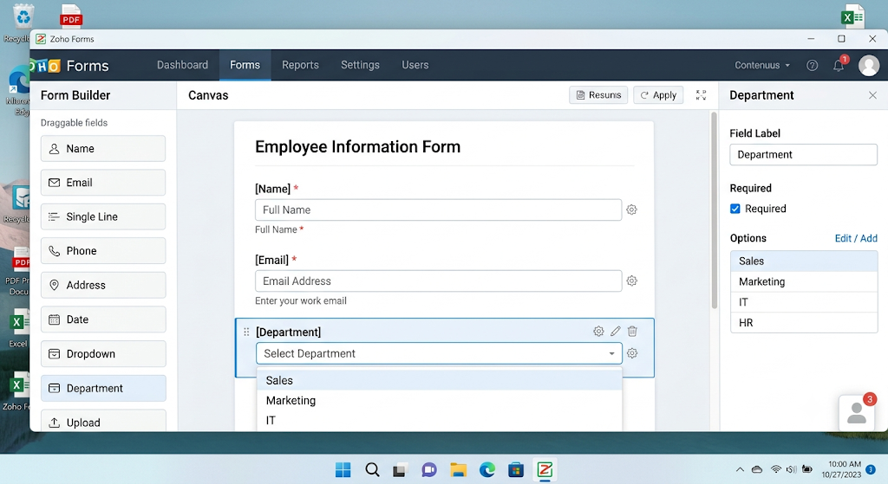

- Creating a report: Reports allow you to view, filter and organize records submitted via forms.
Steps to Execute:-
- Click + Create New -> Select Report. Select the underlying source form (e.g., Employee Entry Form).
- Choose the report display type (e.g., List View, Grid View, or Kanban).
- Configure fields to display, apply filters, and click Done.
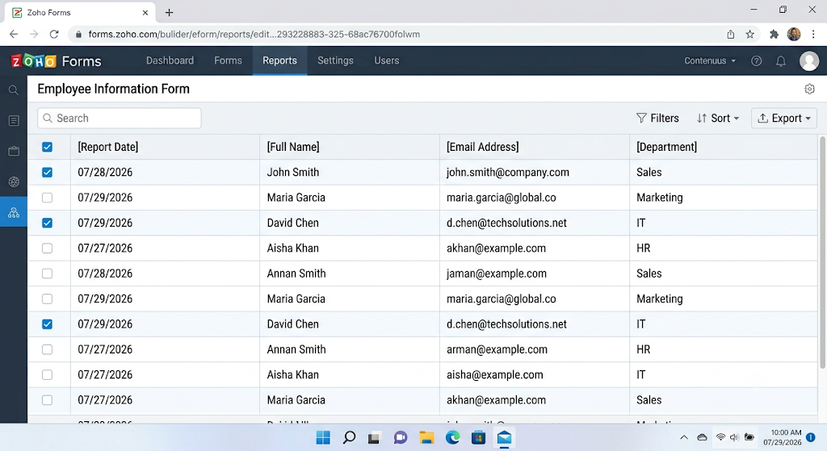

C. Creating a Dashboard: Dashboards provide high-level visual analytics and business key metrics.

Steps to Execute:-
  - Click + Create New -> Select Page / Dashboard.
  - Drag visual elements onto the canvas (e.g., Panels, Charts, Gauge Charts, or embedded Reports).
  - Map the charts to your report data source to summarize key figures (e.g., total count of records, status distribution).
  - Save and preview the dashboard.
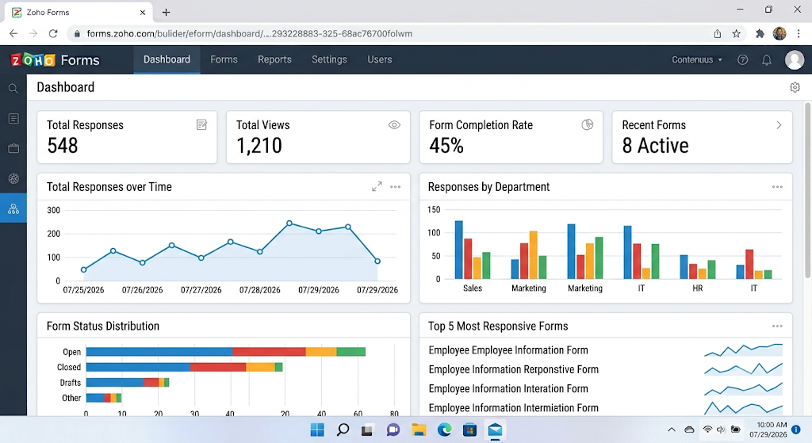

- Exploring Platform Architecture and Interface: The Zoho Creator architecture spans three key stages of the application lifecycle: Develop, Deploy, and Manage.

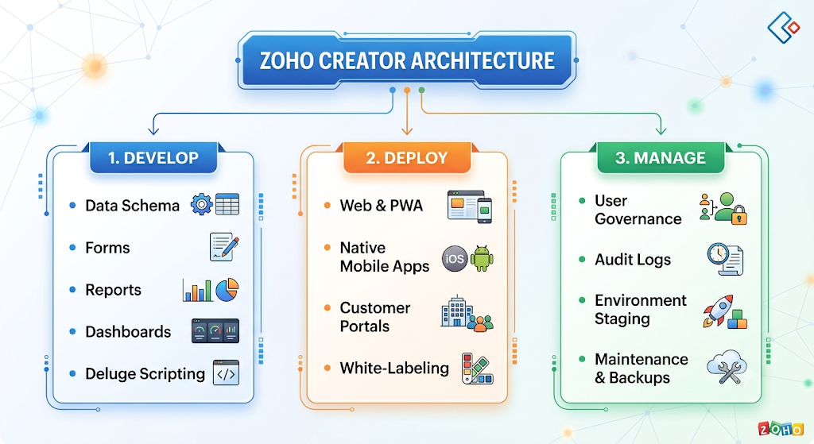

A. DEVELOP: The Develop phase encompasses all tools used to structure data, design user interfaces, and write business logic.
- Data Schema & Models: The core relational database structure where entities, fields, data types, and relationships (1-to-1, 1-to-many, lookup fields) are defined.
- Forms (Data Input): Graphical interfaces designed with drag-and-drop elements to collect user input, enforce validation rules, and write records to tables.
- Reports (Data Visualization): Components that fetch database records and render them in structured formats like Lists, Spreadsheets, Calendars, Maps, or Timelines.
- Dashboards & Pages (Business Intelligence): Custom UI canvases that aggregate key performance indicators (KPIs), metrics, static text, widgets, and charts into a single view.
- Workflows & Deluge Scripting (Automation): Low-code/no-code drag-and-drop workflow builders combined with Deluge (Zoho’s proprietary scripting language) to execute programmatic actions, email notifications, custom APIs, and backend business logic based on events.
B. DEPLOY: The Deploy phase covers multi-channel distribution, rendering, and access options across web, mobile, and external gateways.
- Web & Progressive Web App (PWA): Applications automatically compile into responsive web applications accessible via web browsers or installable PWAs.
- Native Mobile App Generation: Automatic generation of iOS and Android native apps with cross-device layout adaptation and offline sync support.
- Customer & Vendor Portals: Dedicated, isolated access gateways for external stakeholders (clients, suppliers) to submit forms and view tailored data securely.
- White-Labeling & Mobile Device Management (MDM): Ability to rebrand applications with custom domains, custom logos, and deploy directly across enterprise devices via Enterprise MDM suites.

C. MANAGE: The Manage phase focuses on administration, security, environment lifecycle control, and system health monitoring.
- User Management & Role-Based Access Control (RBAC): Granular permission settings dictating which users, roles, or departments can view, edit, or delete specific forms, records, or fields.
- Lifecycle Management (Environments): Multi-stage deployment pipelines (Development, Staging / Sandbox, and Production) ensuring safe testing before code changes go live.
- Audit Logs & System Metrics: Tracking user activity, field-level revisions, system execution logs, and API execution histories for accountability and debugging.
- Backups & Security Infrastructure: Automated data backups, compliance standards, encryption at rest and in transit, and platform health monitoring.

